*IMIT 2022*

INTERNATIONAL Medical Informatics and Telemedicine

V Meeting

Digital Medicine&e-Health

Special and urgent edition againist the war in Ukraine

Peace in Europe and cooperation in the World

*Teleemergency, Telemonitoring and Telerehabilitation,IoT, Robotics*

*Artificial Intelligence, Big Data,CyberSecurity&DataPrivacy,*

*Info-Biomedical Technology (IBT), Info-Assistive Technology (IAT)*

***April 11, 2022***

**International Webinar**

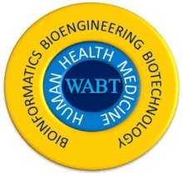

**International Institute of Tele-Medicine**

**Istituto Internazionale di Tele-Medicina**

**Associazione Italiana di Telemedicina ed Informatica Medica**

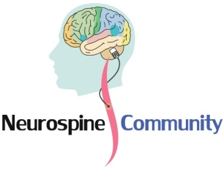

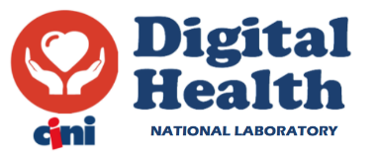

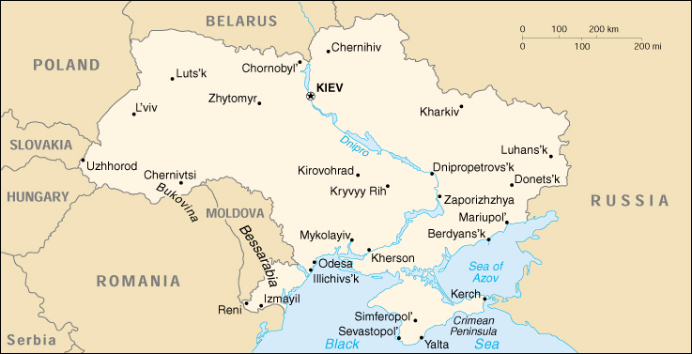

***Program***

**H 9.15 Accessing of participants to the Workshop/Webinar**

**H 9.30 Presentation and introduction of the special and urgent meeting**

* **Francesco Sicurello (**ITB-CNR, president IITM/@ITIM
* **Mario Bochicchio** (University of Bari and Digital Health of CINI Universities Consortium)
* **Massimo Casciello** (Ministry of Health, Italy)
* **Representatives of Health, Research, Academc and Digital Authorities** (CNR, Ministries of Health, of University and Research, of Foreign Affairs and Cooperation, of Digitalization, …)**\***

**H 10.00 Digital Health and Telemedicine in emergency (disasters, pandemics, wars): systems and services**

* **Gianni Pellicanò** (Neuroradiology at Careggi Hospital of Florence, coordinator of @itim scientific council, Italy)
* **Nikolay Bayazitov** (Medical Director, Odesa Regional Hospital, Ukraine)
* **Judita Kinkorova** (University Hospital and Faculty of Medicine in Pilsen, Czech Republic)
* **Paolo Milia** (Rehab Institute Prosperius and University of Perugia)
* **Tetiana Shmelova (**National Aviation University, Kyiv**)**
* **Fabrizio Clemente** (CNR Italy)

**H 11.00 Biomedical Devices, IoT sensors, Robotics, telemonitoring and rehabilitation**

* **Wojciech Glinkowski** (Warsaw Univ, President of Telemedicine Society, Poland)
* **Leonid Godlevsky**(Chief of Department of Biophysics, Informatics and Medical Devices, Odesa National Medical University, Ukraine)
* **Stefano Mazzoleni** (Politechnic of Bari, Italy)
* **Mauro Grigioni** (National Institute of Health - ISS Roma)
* **Alessandro Orro** (CNR Italy)
* **Antonio Graziano** (President /CEO Gruppo Rigenera HBW)

**H 12.00 AI, Biosecurity, Cyber security and data privacy**

* **Giancarlo Mauri** (Professor Emeritus, University of Milano Bicocca)
* **Abdel-Badeeh M. Salem** (Professor of Computer Science, Ain Shams Uni, Cairo, Egypt)
* **Asma Hasan Sbaih** (PhD in engineering of information technology  Bethlehem, Palestine)
* **Giuseppe Tritto** (President WABT Paris)
* **Luis Kun** (Distinguished Professor Emeritus of National Security Affairs, USA)
* **Giuseppe Mastronardi** (University of Bari and AICA, Italy)
* **Giovanni Casiraghi** (Health Management SIPMeL, National Secretary NewMicro)

**H 13.00 break**

**H 14.00 e-Health in the international cooperation between countries**

* **Matteo Botteghi** (University Polithecnic of Marche, World Connex-MedExpo)
* **Alberto Lazzèro** (Hopital de Briançon, Francia)
* **Hassan Ghazal** (CNRST, Rabat/UM6SS, Casablanca)
* **Mauro Giacomini** (University of Genoa, Italy)
* **Antonio Procopio** (Polytechnic University of Marche)
* **Stefano Martinotti** (University of Chieti-Pescara)
* **Gabriele Concordia** (Asst CTO-Pini Milano, AIT@SIT)
* **Jolanda Luongo** (Tsrm neolaureata, Verona)
* **Stefano Guzzetti** (Associazione Patologi Oltre Frontiera ONG)
* Informatici Senza Frontiere APS

**Participants and invited:**

**Mohamed Abdalla,…… and other members of Scientific Committee**

**Chairman: Francesco Sicurello** (President of IITM/@ITIM, CNR-ITB)

**Co-Chairs: Nikolay Bayazitov** (Medical Director of the Odessa Regional Clinical Hospital, Ukrai**ne), Sergio Bella** (Children Hospital Bambino Gesù, Rome Vatican City, @ITIM Vice-president)**, Mario Bochicchio** (University of Bari and Digital Health of CINI Universities Consortium), **Matteo Botteghi** (University Polithecnic of Marche, World Connex-MedExpo)**, Fabrizio Clemente** (IC-CNR, Roma, AURN Santobono Pausilipon Napoli), **Wojciech Glinkowski (**Warsaw Univ, President of Telemedicine Society, Poland), **Leonid Godlevsky** (Chief of Department of Biophysics, Informatics and Medical Devices, Odesa National Medical University, Ukraine), **Stefano Mazzoleni** (Politechnic of Bari, Italy), **Gianni Pellicanò** (Neuroradiology at Careggi Hospital of Florence, coordinator of @itim scientific council)

**Secretariat Committee**

**Silvia Carattoni** (WorldConnex-MedExpo),**Giacomo Sicurello**(Neurospine/IITM)

**Scientific Committee**

***Mohamed Abdalla (Egypt)***

***Konstantin Apthikin (Ukraine)***

***Zoltán Alexin (Hungary)***

***Christian Axiak (Malta)***

***Essam Ayad (Egypt)***

***Claudio Azzolini (Italy)***

***Mihaela Badeea (Romania)***

***Salem Abdel Badeeh M. (Egypt)***

***Georges Badr (Lebanon)  
Ahmed Bahnassy (Saudi Arabia)***

***Manana Beruchashvili (Georgia)***

***Donatella Bonaiuti (Italy)***

***Carlo Bottari (Italy)***

***Marcello Bracale (Italy)***

***Bouchra Chaouni (Morocco)***

***Josephine Borrillo (USA)***

***Luca Buccoliero (Italy)***

***Nello Balossino (Italy)***

***Michelangelo Bartolo (Italy)***

***Federico Cabitza (Italy)***

***Massimo Casciello (Italy)***

***Gianluca Castelnuovo (Italy)***

***Branko Celler (Australia)***

***Paolo Cristiani (Italy)***

***Angela Colantonio (Canada)***

***Prasad Dandamudi (India)***

***Marco De Marco (Italy)***

***Giuseppe De Pietro (Italy)***

***Gaetano Dipietro (Italy)***

***Zoran Dogas (Croatia)***

***Xheladin Duracini (Albania)***

***Bassant M. Elbagoury (Egypt)***

***Ahmed Elbousify (Libya)***

***Themis Exarchos (Greece)***

***Veska Georgieva (Bulgaria)***

***Hassan Ghazal (Morocco)***

***Habib Ghedira (Tunisia)***

***Mauro Giacomini (Italy)***

***Hugo Góngora Jara (Argentina)***

***Mauro Grigioni (Italy)***

***Johnny Heubri (Lebanon)***

***Miguel Hilario (Peru)***

***Kiyomu Ishikawa (Japan)***

***Novak Jaucokic (Montenegro)***

***Klaus Kayser (Germany)***

***Okba Kazar (Algeria)***

***Alda Kika (Albania)***

***Judita Kinkorova (Czech Republic)***

***Ekaterine Kldiashvili (Georgia)***

***Vassiliki Koufi (Greece)***

***Luis Kun (USA)***

***Halina Kwasnicka (Poland)***

***Alberto Lazzèro (Italy&France)***

***Artem Liashenko (Ukraine)***

***Dario Liebermann (Israel)***

***Anamarija Margan (Croatia)***

***Sana Daya Marini (Qatar)***

***Urszula Markowska-Kaczmar (Poland)***

***Rytis Maskeliunas (Lithuania)***

***Giuseppe Mastronardi (Italy)***

***Aziz El Matri (Tunisia)***

***Giancarlo Mauri (Italy)***

***Nébila Mezghani (Tunisia)***

***Silvestro Micera (Italy&Switzerland)***

***Luciano Milanesi (Italy)***

***Paolo Milia (Italy)***

***Maite Mijares (Ecuador)***

***Ghawil Millad (Libya)***

***Paolo Mocarelli (Italy)***

***Ioana Moisil (Romania)***

***Josè Luis Monteagudo Pena (Spain)***

***Sandro Mussa-Ivaldi (USA)***

***Zahraa Noureddine (Lebanon)***

***Jiří Ochozka (Czech Republic)***

***Antonio Oliviero (Spain)***

***Alessandro Orro (Italy)***

***Giancarlo Pallavicini (Italy)***

***George Pangalos (Greece)***

***Immacolata Pannone (Italy)***

***Luca Papi (Italy)***

***Monica A. Perez (USA)***

***Maddalena Pezzotti (ONU)***

***Domenico Pisanelli (Italy)***

***Simion Pruna (Romania)***

***Mohamed Wasim Raad (Saudi Arabia)***

***Jasmina Radojlović (Serbia)***

***Liliana Rogozea (Romania)***

***Andrejs Romānovs (Latvia)***

***Lorenzo Rossano (Italy)***

***A. K. Sangal (India)***

***Eugenio Santoro (Italy)***

***Asma Hasan Sbaih (Palestine)***

***Boris Schmit (Germany)***

***Ghassan Shahrour (Syria)***

***Najeeb Al Shorbaji (Jordan)***

***Pal Simon (Hungary)***

***Enrico M. Staderini (Switzerland)***

***Giulia Stampacchia (Italy)***

***Valery Stolyar (Russia)***

***Peter Tonellato (USA)***

***Oswaldo Trelles (Spain)***

***Giuseppe Tritto (Italy&France)***

***Eleonora  Veglianti (France)***

***Jorge A. Vélez B. (Colombia)***

***Luigi Vladareanu (Romania)***

***Peter Waegemann (USA)***

***Steve Wheeler (UK)***

***Yukako Yagi (USA)***

***Antoniya Yanakieva (Bulgaria)***

***Maša Ždralević (Montenegro)***

***Floriana Zennaro (Italy)***

***Maria Zolfo (Belgium)***

***Tatjana Zrimec (Slovenia)***