*IMIT 2023*

INTERNATIONAL Medical Informatics and Telemedicine

VI Meeting

TeleMedicine & Digital Health

for Peace in Europe and cooperation in the World

(1 Year after the war in Ukraine and 3 years after covid 19 first Case in Italy/Europe)

*Telemedicine in Emergency Care (disasters, pandemics, wars)*

*Telemonitoring and Telerehabilitation, IoT, Robotics*

*Info-Biomedical Technology (IBT), Digital Assistive Technology (DAT)*

*Artificial Intelligence, Big Data, CyberSecurity*

Special International Webinar

***February 28, 2023***

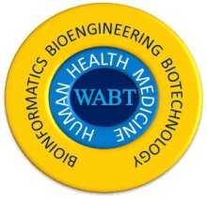

**International Institute of Tele-Medicine**

**Istituto Internazionale di Tele-Medicina**

**Associazione Italiana di Telemedicina ed Informatica Medica**

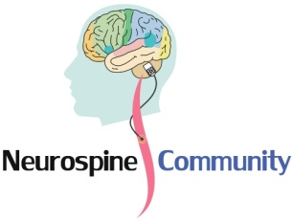

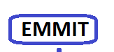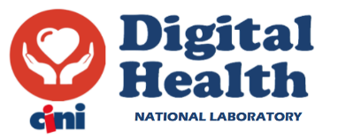

**Euro-Mediterranean Medical**

**Informatics and Telemedicine**

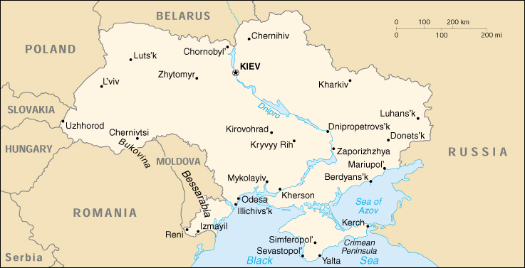

***Introduction and program of Webinar***

At this crucial time, weeks after a major Sirian and Turkey earthquake, 1 year into the war in Ukraine and 3 years since the first recorded Covid-19 case in Italy/Europe, IMIT is hosting a special VIth Telemedicine and Digital Health webinar promoting telemedicine supporting peace and worldwide cooperation. Telemedicine, as IT infrastructure, remote education, and food and water access programs, has a tremendous potential to help relieve suffering, promote justice and provide highly impactful healthcare worldwide, especially in underserved and high risk locations where it is needed the most. This webinar will gather telemedicine experts from around the world to discuss how key topics including: Telemedicine; Telemonitoring and Telerehabilitation; IoT; Big Data; Robotics; Info-Biomedical Technology (IBT); Digital Assistive Technology (DAT); Artificial

Intelligence; CyberSecurity can be deployed, configured and applied in manner that will provide key emergency needs during disasters such as pandemics, droughts; earthquakes and wars.

**H 9.15 Accessing of participants to the Workshop/Webinar**

**H 9.30 Presentation and introduction to the special meeting**

* **Francesco Sicurello** (ITB-CNR Senior Associate researcher, President of IITM/@ITIM)
* **Leonid Godlevsky**(Chief of Department of Biophysics, Informatics and Medical Devices, Odesa National Medical University, Ukraine)
* **Mario Bochicchio** (University of Bari and Director of Digital Health Lab. of CINI Universities Consortium)
* **James Goldberg** (International Academy Health USA Global Health, Palmes Académiques France)
* **Giancarlo Pallavicini** (President of FGP, Prof. Emeritus in Economy)

**H 10.00 Digital Health and Telemedicine in emergency (disasters, pandemics, wars): e-Health in the international cooperation between countries (**Chair. **Claudio Azzolini,** Professor Emeritus of University of Insubria, Varese)

* **Gianni Pellicanò** (Neuroradiology at Careggi Hospital of Florence, coordinator of @itim scientific council, Italy)
* **Wojciech Glinkowski** (Warsaw Univ, President of Telemedicine Society, Poland)
* **Alberto Lazzèro** (Hopital de Briançon, Francia)
* **Hassan Ghazal** (Adjunct Professor, University Mohammed VI of Health Sciences & National Center for Scientific and Technological Research, Morocco)
* **Rytis Maskeliūnas** (Kaunas University of Technology, Lithuania)
* **Fabrizio Clemente** (CNR Rome, Italy)
* **Judita Kinkorova** (University Hospital and Faculty of Medicine in Pilsen, Czech Republic)
* **Thulasi Bai** (Telemedicine Society of India)
* **Stefano Guzzetti** (Associazione Patologi Oltre Frontiera ONG)
* **Asma Hasan Sbaih** (PhD in engineering of information technology  Bethlehem, Palestine)

**H 11.30 Biomedical Devices, IoT sensors, Robotics, telemonitoring and rehabilitation (**Chair. **Abdel-Badeeh M. Salem,** Professor Emeritus of Ain Shams University, Cairo, Egypt)

* **Sergio Bella** (Children Hospital Bambino Gesù Rome, Vice-president of @itim)
* **Matteo Botteghi** (University of Rimini, World Connex-MedExpo)
* **T. V. Gopal (**Anna University, Chennai, India)
* **Alessandro Orro** (CNR-ITB Milan, Italy)
* **Bassant M. Elbagoury** (Ain Shams University, Cairo, Egypt)
* **Stefano Mazzoleni** (Politechnic of Bari, Italy)
* **Paolo Milia** (NeuroRehab Chair, Institute of Umbertide and University of Perugia, Italy)
* **Luige Vladareanu** (Romanian Academy, Institute of  Solid Mechanics, President of the Romanian Robotics Society, Bucharest, Vice.president of SRR, Robotic Society of Romania)
* **Mauro Grigioni** (Head of Centre of Innovation Technology, National Institute of Health – ISS, Rome, Italy)

**H 12.45 break**

**H 14.00 AI, Big Data, Cyber security, Biosecurity and data privacy (**Chair. **Giuseppe Mastronardi,** University of Bari and AICA, Italy)

* **Giancarlo Mauri** (Professor Emeritus, University of Milano Bicocca**)**
* **Peter J. Tonellato** (University of Missouri and Harvad University, USA)
* **Giuseppe Tritto** (President of WABT Paris)
* **Luis Kun** (Distinguished Professor Emeritus of National Security Affairs, USA)
* **Claudio Ferretti** (University of Milano Bicocca)
* **Pál Miletics** (Telemedicine and e-Health, Hungary)
* **Mauro Giacomini** (University of Genoa, Italy)

**H 15.30 Tutorial per operatori sanitari (in particolare Ucraini in Italia) su Tecnologie biomediche e sanitarie: dispositivi medicali, aspetti tecnologici e normativi**

* **Pierluigi Aloe** (Asst 7 Laghi, Varese)
* **Giovanni Casiraghi** (NewMicro e SIPMeL)
* **Paola Ferrari** (Studio Legale Ferrari, Milano)

**Chairman: Francesco Sicurello** (President of IITM/@ITIM, CNR-ITB)

**Co-Chairs: Peter J. Tonellato** (University of Missouri and Harvad University, USA)

**Leonid Godlevsky** (Chief of Department of Biophysics, Informatics and Medical Devices, Odesa National Medical University, Ukraine)

**Wojciech Glinkowski** (Warsaw Univ, President of Telemedicine Society, Poland)

**Secretariat**

### Silvia Carattoni (WorldConnex-MedExpo),Olena (Elena) Oboysheva (Mediatrice culturale Italia-Ucraina)

**Scientific Committee**

***Mohamed Abdalla (Egypt)***

***Konstantin Apthikin (Ukraine)***

***Zoltán Alexin (Hungary)***

***Christian Axiak (Malta)***

***Essam Ayad (Egypt)***

***Claudio Azzolini (Italy)***

***Mihaela Badeea (Romania)***

***Salem Abdel Badeeh M. (Egypt)***

***Georges Badr (Lebanon)  
Ahmed Bahnassy (Saudi Arabia)***

***Nello Balossino (Italy)***

***Nikolay Bayazitov (Ukraine)***

***Sergio Bella (Italy)***

***Manana Beruchashvili (Georgia)***

***Mario Bochicchio (Italy)***

***Donatella Bonaiuti (Italy)***

***Josephine Borrillo (USA)***

***Carlo Bottari (Italy)***

***Matteo Botteghi (Italy)***

***Luca Buccoliero (Italy)***

***Andrea Capra (Italy)***

***Massimo Casciello (Italy)***

***Branko Celler (Australia)***

***Fabrizio Clemente (Italy)***

***Paolo Cristiani (Italy)***

***Angela Colantonio (Canada)***

***Prasad Dandamudi (India)***

***Giuseppe De Pietro (Italy)***

***Gaetano Dipietro (Italy)***

***Bassant M. Elbagoury (Egypt)***

***Ahmed Elbousify (Libya)***

***Veska Georgieva (Bulgaria)***

***Hassan Ghazal (Morocco)***

***Habib Ghedira (Tunisia)***

***Mauro Giacomini (Italy)***

***James Goldberg (USA&France)***

***T. V. Gopal (India)***

***Hugo Góngora Jara (Argentina)***

***Mauro Grigioni (Italy)***

***Johnny Heubri (Lebanon)***

***Miguel Hilario (Peru)***

***Kiyomu Ishikawa (Japan)***

***Novak Jaucokic (Montenegro)***

***Klaus Kayser (Germany)***

***Alda Kika (Albania)***

***Judita Kinkorova (Czech Republic)***

***Ekaterine Kldiashvili (Georgia)***

***Vassiliki Koufi (Greece)***

***Luis Kun (USA)***

***Halina Kwasnicka (Poland)***

***Alberto Lazzèro (Italy&France)***

***Artem Liashenko (Ukraine)***

***Dario Liebermann (Israel)***

***Anamarija Margan (Croatia)***

***Sana Daya Marini (Qatar)***

***Urszula Markowska-Kaczmar (Poland)***

***Rytis Maskeliunas (Lithuania)***

***Giuseppe Mastronardi (Italy)***

***Aziz El Matri (Tunisia)***

***Giancarlo Mauri (Italy)***

***Stefano Mazzoleni (Italy)***

***Nébila Mezghani (Tunisia)***

***Silvestro Micera (Italy&Switzerland)***

***Luciano Milanesi (Italy)***

***Paolo Milia (Italy)***

***Maite Mijares (Ecuador)***

***Ghawil Millad (Libya)***

***Paolo Mocarelli (Italy)***

***Ioana Moisil (Romania)***

***Josè Luis Monteagudo Pena (Spain)***

***Sandro Mussa-Ivaldi (USA)***

***Zahraa Noureddine (Lebanon)***

***Jiří Ochozka (Czech Republic)***

***Antonio Oliviero (Spain)***

***Alessandro Orro (Italy)***

***Giancarlo Pallavicini (Italy)***

***George Pangalos (Greece)***

***Immacolata Pannone (Italy)***

***Luca Papi (Italy)***

***Gianni Pellicanò (Italy)***

***Monica A. Perez (USA)***

***Maddalena Pezzotti (ONU)***

***Domenico Pisanelli (Italy)***

***Simion Pruna (Romania)***

***Mohamed Wasim Raad (Saudi Arabia)***

***Jasmina Radojlović (Serbia)***

***Liliana Rogozea (Romania)***

***Andrejs Romānovs (Latvia)***

***Lorenzo Rossano (Italy)***

***A. K. Sangal (India)***

***Eugenio Santoro (Italy)***

***Asma Hasan Sbaih (Palestine)***

***Boris Schmit (Germany)***

***Ghassan Shahrour (Syria)***

* ***Tetiana Shmelova (Ukraine)***

***Najeeb Al Shorbaji (Jordan)***

***Pal Simon (Hungary)***

***Enrico M. Staderini (Switzerland)***

***Giulia Stampacchia (Italy)***

***Peter Tonellato (USA)***

***Oswaldo Trelles (Spain)***

***Giuseppe Tritto (Italy&France)***

***Eleonora  Veglianti (France)***

***Jorge A. Vélez B. (Colombia)***

***Luigi Vladareanu (Romania)***

***Steve Wheeler (UK)***

***Yukako Yagi (USA)***

***Antoniya Yanakieva (Bulgaria)***

***Maša Ždralević (Montenegro)***

***Maria Zolfo (Belgium)***

***Tatjana Zrim***